**INSTALLATION OF PYTHON 3.7.4**

Team Id : PNT2022TMID31048

Project Title : Personal Assistance For Seniors Who Are Self-Reliant

STEP 1: Type python in Google and click on the first link.



STEP 2: Click the python 3.7.4

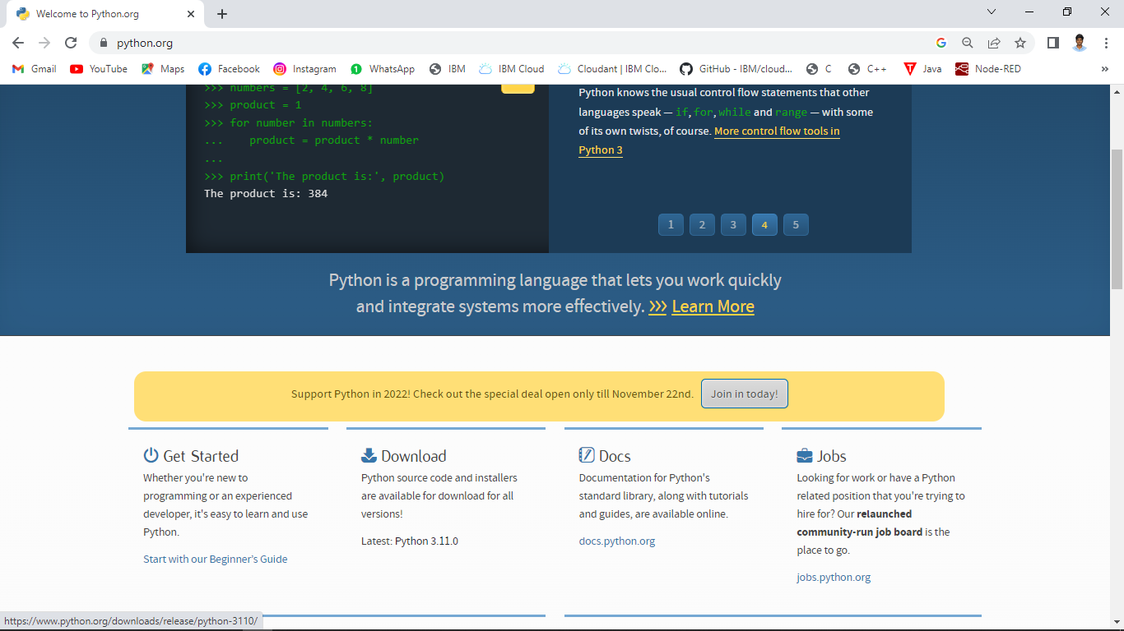

STEP 3: Scroll down to reach the Files and click windows installer 64 bit.

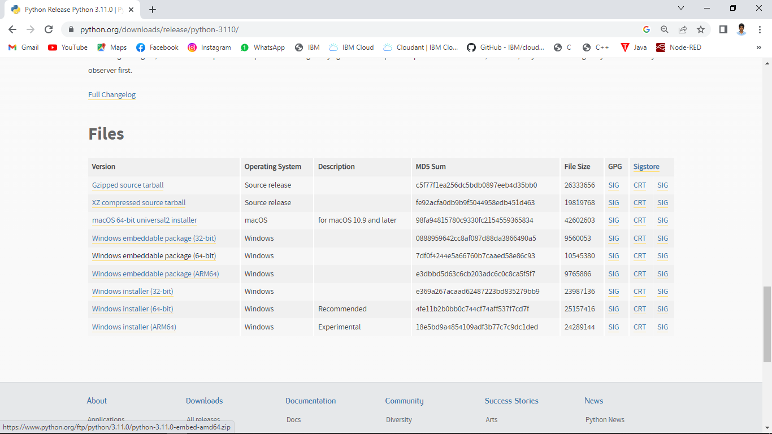

STEP 4: To change the path click on the second check box Add python 3.7 to PATH and then click the customize installation.

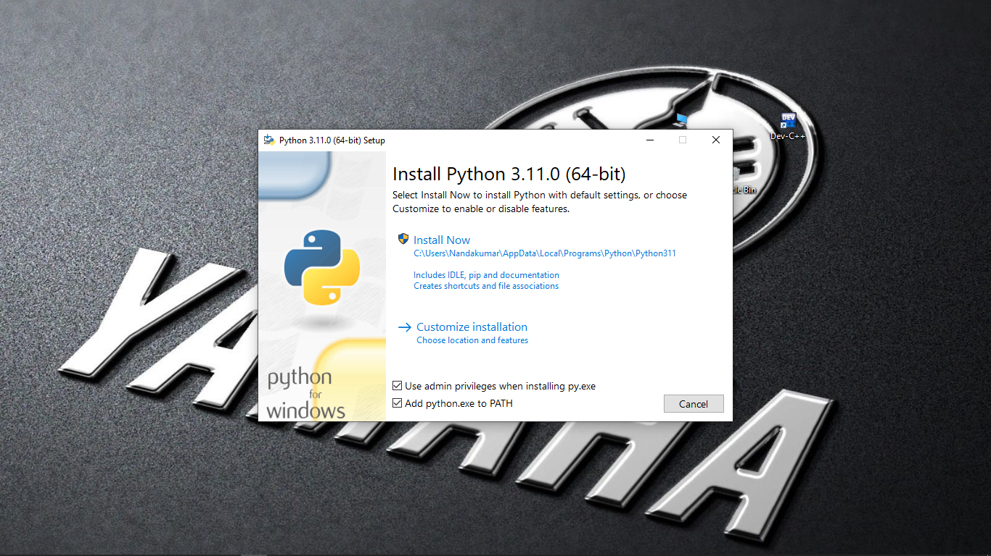

STEP 5: Click the Next button.

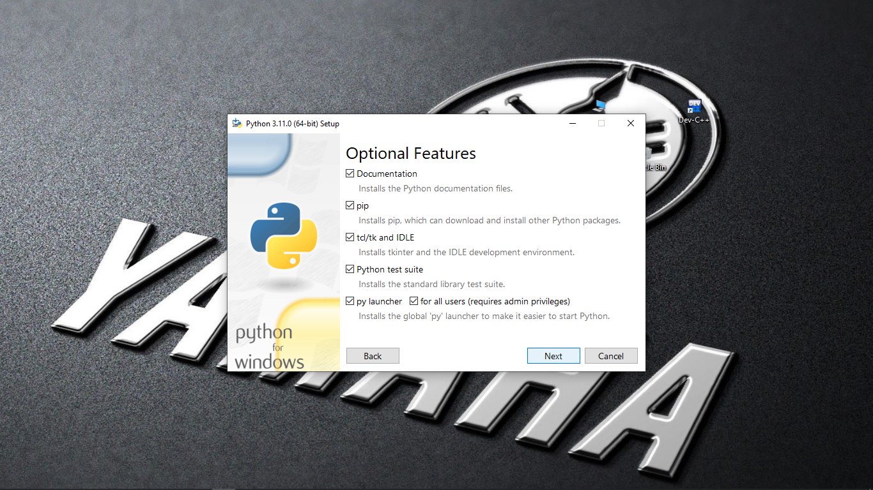

STEP 6: You can change the path here and click on the install button

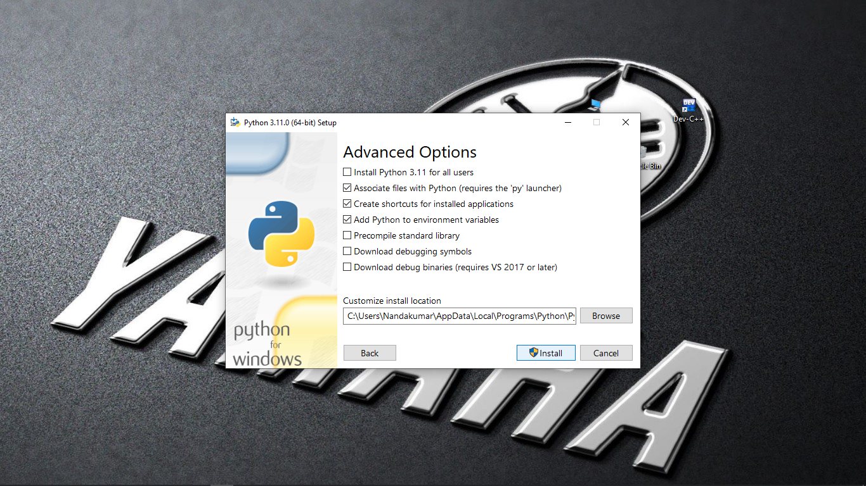

STEP 7: Installation process.

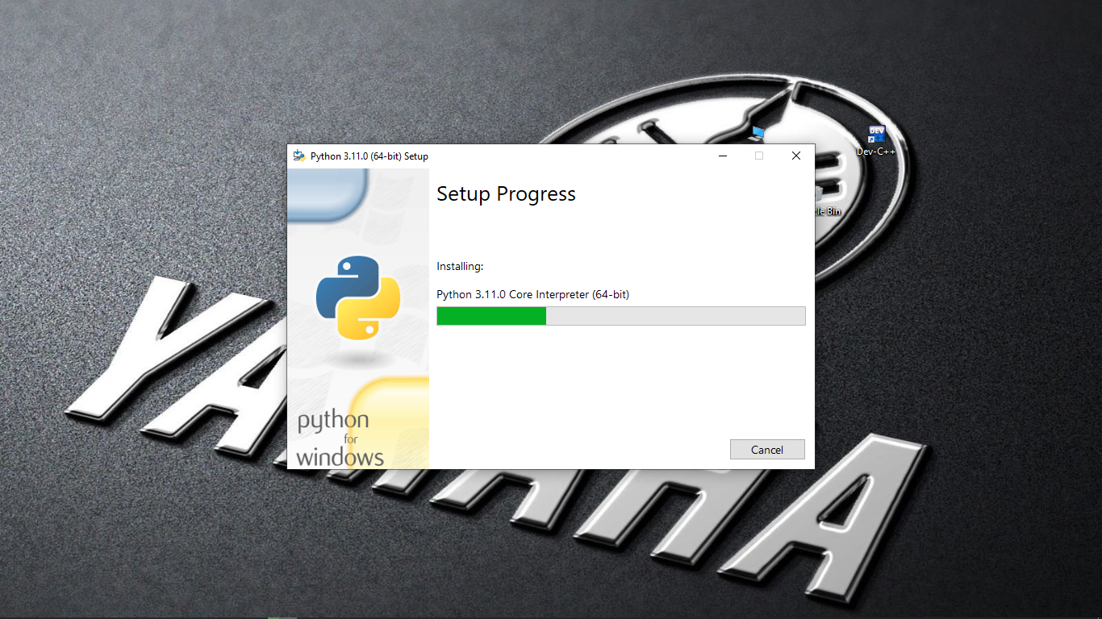

STEP 8: Click the close button.

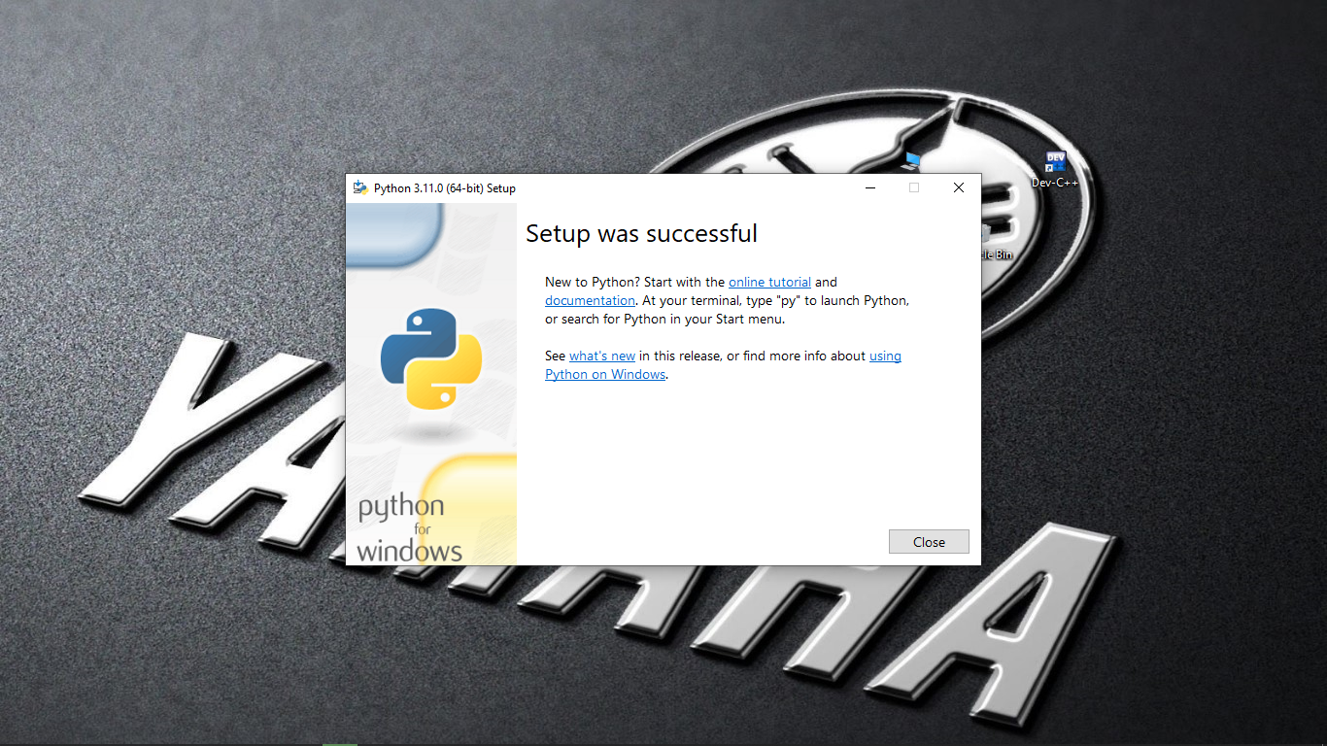

STEP 9: To check whether it is working click the windows icon , click the All apps

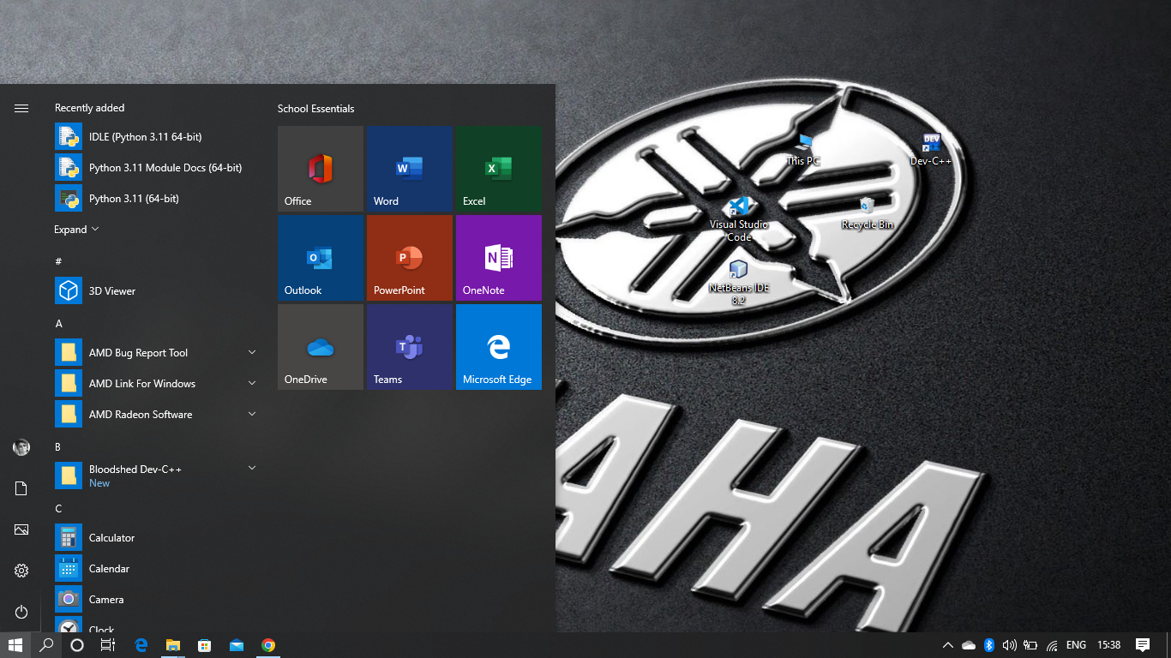

STEP 10: Click the IDLE (python 3.7 64-bit).

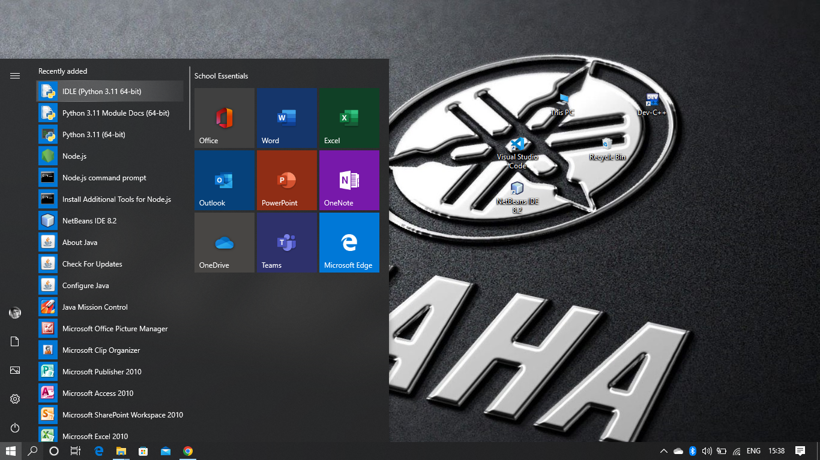

STEP 11: This is the IDLE window.

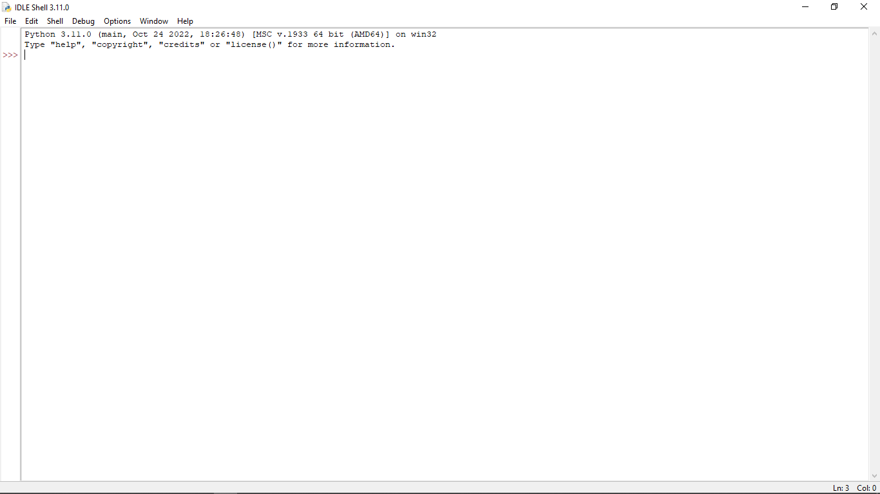

STEP 12: Click the Python 3.7 (64-bit).

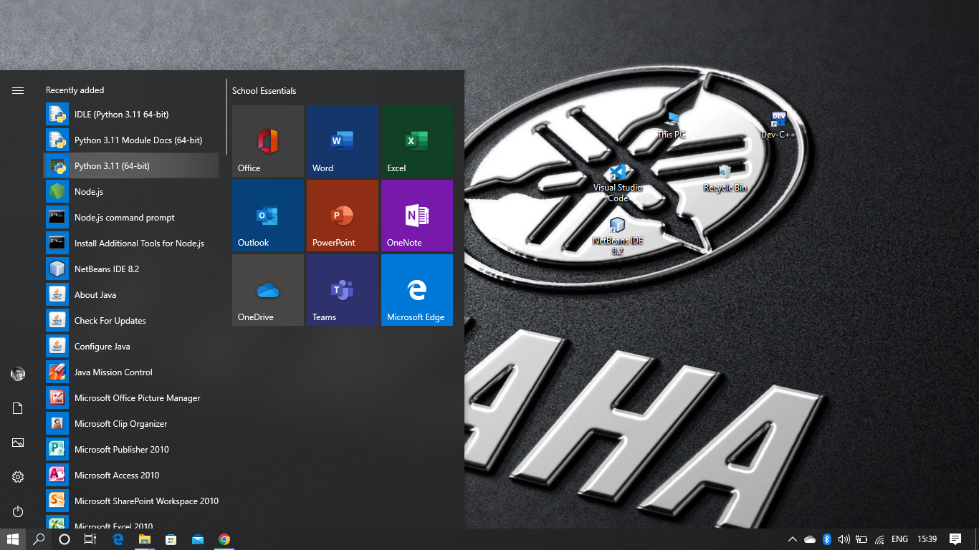

STEP 13: This is the Python 3.7 (64-bit) command prompt

